Time Series Midterm Summer 2020

In-Class Portion

Please put your answers directly on this Word document. When completed, please submit the completed Word doc to the “Midterm” assignment on 2DS and email the test back to me at [bsadler@smu.edu](mailto:bsadler@smu.edu). The take home portion will be due by 11:59pm on Saturday, June 27 and that should be submitted on 2DS under the Midterm assignment as well (and emailed to me.) You can find the take home portion on Github in the Unit 8 folder**. By taking this test you are agreeing to not communicate with any human being (except for Bivin Sadler) about the in-class or take home portion of this test. You may use your notes, the book, the internet, etc. …. Just no live human or AI (unless you have a question for me.)**

Note throughout the test: “By hand” simply means show your work as if you were writing it by hand. You may actually write it by hand and take a pic or you may type it.

***FYI:Complex equations are typed in Google Docs and Screenshotted to paste in word. I have more experience with and work faster with the equations in Google Docs.***

The following data are quarterly sales (in units sold) for a make-believe company:

|  |  |
| --- | --- |
| Time | Units |
| 1 | 1 |
| 2 | 5 |
| 3 | 10 |
| 4 | 9 |
| 5 | 4 |
| 6 | 6 |
| 7 | 12 |

1. (4pts) Compute ${\hat{γ}}_{0}$ by hand.

**The Autocovariance at zero lag is equal to the variance of the data. Given an N of 7 we can calculate the mean below rounded to two decimal placed:**

**(1+5+10+9+4+6+12) / 7 = 6.71**

**Following the equation below, I calculated the auto covariance**

${\hat{γ}}_{0}$****

**= Sum ( (1-6.71)^2 (5-6.71)^2 (10-6.71)^2 (9-6.71)^2 (4-6.71)^2 (6-6.71)^2 (12-6.71)^2) / 7**

**= (32.6 + 2.92+10.82+5.24+7.34+.50+27.98) / 7**

**= 12.49**

**The autocovariance at lag 0 is 12.49**

1. (4pts) Compute ${\hat{γ}}_{6}$ by hand.

**Again we follow the same basic equation as above, but due to the fact there are only 7 samples, there is only one pair that can be calculated to compute the autocovariance at lag 6.**





**The autocovariance at lag 6 is -4.32, but again that is only calculated with one pair of observations and may be a less confident estimate than smaller lag calculations.**

1. (4 pts) Compute ${\hat{ρ}}_{6}$ by hand.

**Using the formula below, the autocorrelation at lag 6 is calculated to be -.345.**



Using the data above, consider the Model: $\left(1-.4B\right)(1+.2B)(X_{t}-μ)=a_{t}$ where the phis are estimated and $μ$ is unknown but not assumed to be zero.

1. (4 pts) Compute ${\hat{X}}_{7}$ (1) by hand showing your work. You may work it on paper and submit a pic / scan of your work or you may simply type what you would have written by hand.

**Multiplying the polynomials given with mult.wge gives us the phis of .2 and .08.**



**The general equation to forecast one element forward is below. Where since we do not know the true mean, we must estimate the mean to be 6.71.**



**The filled in equation is below and the forecasted next element is 7.71**





1. (6 pts) Compute a 95% probability interval for ${\hat{X}}_{7}$ (1) by hand. “By hand” means show your calculation of the margin of error as we did in live session. However, in your calculation, you should assume that your client has asked you to use ${\hat{σ}}_{a}$ = 3.0. A value that they calculated in another study that they prefer to continue to use in this study.

**Given the data at hand and assuming a White noise variance of 3, the half width at ${\hat{X}}_{7}$** (1) **is 3.46.**

We have: MOE = ${z_{α/2} * \hat{σ}}_{a} \sqrt{\sum_{j=0}^{l-1}{ψ_{j}^{2}}}$ **where $z_{α/2}$ = 1.96 for 95% confidence intervals.**



$$MOE=1.96* 3 *\sqrt{1^{2}}=5.88$$

**The 95% prediction interval** = ${\hat{X}}_{7}\left(1\right)±MOE=7.68±5.88$

$$=[1.8 , 13.56]$$

**Fine to either report the half width or the full interval.**

1. (4pts) Write this AR(2) model as a GLP (just the first 4 terms).



**Using the psi weights above the GLP form of the model is below**



1. (4pts) Will this model have stronger (more dominant) wandering behavior, oscillating behavior or periodic behavior with period greater than 2? Why?

**Because it can be factored back into two AR(1) components, it will have the strongest wandering behavior, as the more dominant value is positive while a much less dominant behavior produces slight oscillating behavior.**

1. Matching: Match the letter to the number below the labeled ACFs and realizations. (2pts each )

|  |  |
| --- | --- |
| 1. | A. |
| 2. | B. |
| 3. | C. |
| 4. | D. |
| 5. | E. |

1. _B_ 2. _E_ 3. _C_ 4. _A_ 5. _D_
2. (4pts) Below is a realization of sales data of swimsuits in Dallas, Texas. Talking with a the senior vice president (SVP) of the company that recorded the data, she has indicated that over the past 30 years they have seen below average sales in October and continuing to decline until March in which the sales steadily increase till August in which they begin to decrease through which they fall below average in October and the process repeats. The SVP also stated that she and the industry fully expect these trends to continue for the foreseeable future as swimsuit sales tend to be correlated with the temperature in Dallas, Texas. Below the plot, answer the question, is this data likely generated from a stationary or non-stationary process? Why? (One to three sentences should do!)



Months

Swimsuit Sales

**This is likely a non-stationary process. The major trend that seems clear from the realization present and the domain expertise of the SVP in question indicates there is a regular cyclical seasonal pattern to this data that repeats year after year. If we see future realizations where the data does not follow the expectations the SVP laid out, we still expect it to return to its regular pattern in later years, thus the mean sales relies heavily on time and is non-stationary.**

1. Use the bank of models below to assign possible models to each visual representation of forecasts.(2pts each)

|  |  |
| --- | --- |
| 1. Signal Plus Noise Model with linear trend. 2. Signal Plus Noise Model with Cos trend. 3. AR(1) with a positive real root 4. AR(2) with 2 positive real roots 5. AR(10) with all positive real roots 6. AR(1) with a negative real root | 1. AR(2) with 2 negative real roots 2. AR(10) with all negative real roots 3. AR(2) with complex conjugate roots 4. ARIMA(pdq) with p = 0, q = 0, d = 1 and s = 12. 5. ARIMA(pdq) with p = 2, q = 0, d = 1 and s = 0 |

|  |  |
| --- | --- |
| **Forecasts** | List all possible models that could generate the forecasts to the left. Just put the letter(s) from the model(s) above below. There may be more than one answer. |
| Example: | Answer(s): F,G,H |
|  | Answer(s):K |
|  | Answer(s):C, D, E |
|  | Answer(s):A, |
|  | Answer(s):J |
|  | Answer(s): K |
|  | Answer(s):I |

1. (3 pts) Estimate the period(s) that is/are associated with this spectral density. It just needs to be close… not exact.



**There is some aperiodic wandering trend, with a frequency close to zero. There is also likely a period trend of 5 that is the strongest with a frequency spike at .2 and another lesser period at about 2.5. Short answer: Period of 2.5 and 5 and aperiodic wandering behavior.**

1. (3pts) What are the minimum and maximum number of peaks an AR(7) could have in the true Spectral density?

**An AR(7) could have a maximum of 3 peaks related to three sets of complex conjugate roots and one single real root remaining to make up the seven components (for a total max of 4). Alternatively, it could have only peaks at either 0 and/or .5. An AR(7) model could show one peak at .5 or one at 0 at minimum. In short, min = 1 and max = 4.**

For questions 13-14, consider the model below.

$$\left(1-0.9B+0.2B^{2}+0.94B^{3}+0.6B^{4}\right)X_{t}={(1-.1B)a}_{t}$$

1. (4pts) Describe the behavior of realizations generated from the model. Specifically comment on any wandering, oscillating and or periodic behavior and the dominance of those behaviors in generated realizations.

**The behavior of the AR component is primarily not stationary. The most dominant behavior is a .12 frequency with an absolute reciprocal of 1.28, this is the non-stationary behavior and is dominant in this data.**

**The secondary behavior is a .4 frequency with a less dominant behavior suggested by an absolute reciprocal of the root at .6. This frequency behavior is stationary but would not be as strong as the lower frequency non-stationary behavior.**

1. (4pts) Is the model stationary or non-stationary … invertible or non-invertible? Why?

**This model is non – stationary but invertible. The AR components include a pair of complex conjugate roots that lie inside the unit circle, therefore the absolute reciprocal of those roots are outside the unit circle and stationary. However, the MA component is invertible as it only has one component and that root is outside the unit circle.**

1. (3pts) Assume the data has passed through a filter. The spectral densities are displayed below both before and after the filter is applied to the data. Which is filter was applied to the data?
   1. Moving Average Filter
   2. 1st Difference Filter

BEFORE FILTER: 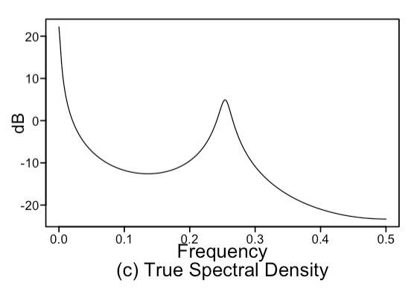AFTER FILTER: 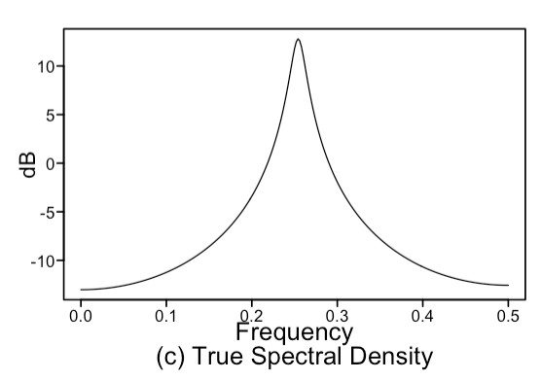

**Answer: B. …. A difference filter was applied to the data as it removed much of the aperiodic or low pass frequency, but the higher level frequency at about .25 remains.**

1. (4pts) Name one reason why we should consider only invertible models?

**One major reason we should only consider invertible models is that we expect our data to have a reasonable relationship with time. If a model is not invertible, then that means as we move further away from the present, the less recent past has more of an effect on the present. Extrapolated this would mean that an event a million days before today has more influence than all the days that have come since including the most recent which does not follow a sensible relationship with time.**

**Short Answer:**

1. **The present is related to the past in a sensible manner.**
2. **Model multiplicity. Invertible models have a unique acf.**
3. (3 pts) True / False Consider the output from a call to aic5.wge() below:

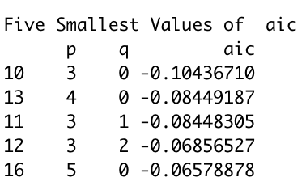

True or False: The ARMA(3,0) model must be more useful in forecasting than the ARMA(3,2) model.

**False, Although the ARMA(3,0) model is preferred by AIC measurement alone, this is not enough evidence that it must be more useful than the ARMA(3,2) model. There could be other useful aspects of the ARMA(3,2) model we don’t capture with this AIC measure alone.**

**TAKE HOME**

Questions 18 – 29 Consider the data on the Wall in the file, *MidtermFall2020Takehome.csv*.

1. (3 pts) First let’s assume the data come from a stationary process. What is the most favored correlation structure (identify p and q) with respect to the AIC? Assume you only want to consider ARMA(p,q) models with p < 15 and q < 5. All you have to do here is identify p and q.





**Using aic5.wge() and restricting it to ARMA models with an AR component below 15 and an MA component below 5, we see the most favored model by AIC alone is the ARMA(11,4) model. The AIC function reported errors in calculations for several larger models which may have contributed to the results.**

1. Next we would like to compare the usefulness of a stationary and non-stationary model in terms of ASE rather than the AIC.
   1. (*6 pts) Find* and report the ASE (and show your code) for a horizon of 24 from the following two models:



$$Model A: \left(1-B^{12})(1+.1B+.7B^{2}\right)X_{t}={(1-.1B)a}_{t}$$

$$Model B: \left(1-.8B\right)X_{t}=a_{t}$$

**Model A Forecast on Data:**



**Model B Forecast on Data:**



**In the above code, Model A and B were used to forecast the last 24 instances of the data in question and both predictions were used to calculate ASEs for each model. Model A’s ASE was 1.29, much smaller than model B’s ASE of 55.77. Visually we can also compare above how Model A’s predictions better match the pattern our realization follows.**

* 1. (1 pt) Given your answer in part a, which model would be most favorable for forecasting the next 24 observations with respect to the ASE?

**Given the ASE above, Model A is the more favorable model to forecast on this data. Of the models we are comparing, Model A is a much closer fit to the pattern of the data and we can reasonably expect it’s predictions to be more accurate than Model B.**

* 1. Use the model you chose in part b to forecast the next 24 observations from the end of the dataset.





**Above model A is used to predict 24 new values after the data we have. Visually this is somewhat tough to see with the high frequency behavior but it seems to follow a similar pattern with the confidence intervals widening the potential values.**

BONUS: Plotting the entire dataset with the forecasts makes the forecasts tough to see and assess. Come up with a good visualization that you would show your client that would clearly show them the 24 forecasts superimposed on the last 24 observations (visualizing the ASE.) Note these are the forecasts used to find the ASE **not** the forecasts from the end of the realization.



**This visualization colors the forecast, original data, and confidence interval to make differentiating them easier. It also segments the data to more recent time, only showing the last fifty observations of data, making the new forecasts easier to see in the limited space. The code to make this plot and organize the data is below.**



**Good work! +2**